

College of Computer Science and Information Technology
تامولعملا ةينقتو بساحلا مولع ةيلك

DEPARTMENT OF COMPUTER ENGINEERING

ARTI403 – Image Processing

STUDENT PROCEDURAL MANUAL Lab 6

2026 - 2027

College | Department | Course
College of Computer Science and Information Technology | Department of  Computer Engineering | ARTI404 – Image  Processing

Practical Session Plan

Session Topic/Title | Session No. | Session Duration  (Minutes)
Frequency Domain | 6 | 100

1- Session Outcomes

Outcome#1: Write a program that implements fundamental image processing algorithms.

2- Tool(s)/Software .
• Python 3
• Anaconda
• IDE for Python: Jupyter, Spyder.
• Libraries: OpenCV, NumPy, Pillow, Skimage, Matplotlib.

3- Procedural steps (Tasks)

Task#1: Filtering in the Frequency Domain

import numpy as np
import matplotlib.pyplot as plt
from skimage import data
from skimage.transform import resize

# Load cameraman image (already grayscale)
image = data.camera()
image = resize(image, (256, 256)) # Resize for faster FFT (optional)

# Get image size
M, N = image.shape

# Generate frequency grid (centered)
u = np.fft.fftfreq(M).reshape(-1, 1)
v = np.fft.fftfreq(N).reshape(1, -1)

# Compute Laplacian filter in frequency domain
laplacian_filter = -4 * (np.pi ** 2) * (u**2 + v**2)

# Apply 2D FFT
F = np.fft.fft2(image)

# Apply Laplacian filter in frequency domain
F_lap = F * laplacian_filter

# Inverse FFT to get spatial result
laplacian_image = np.fft.ifft2(F_lap).real

# Plot results
plt.figure(figsize=(12, 5))

plt.subplot(1, 3, 1)
plt.imshow(image, cmap='gray')
plt.title('Original Cameraman')
plt.axis('off')

plt.subplot(1, 3, 2)
plt.imshow(np.log(1 + np.abs(F_lap)), cmap='gray')
plt.title('Laplacian Spectrum')
plt.axis('off')

plt.subplot(1, 3, 3)
plt.imshow(laplacian_image, cmap='gray')
plt.title('Laplacian (Spatial Output)')
plt.axis('off')

plt.tight_layout()
plt.show()

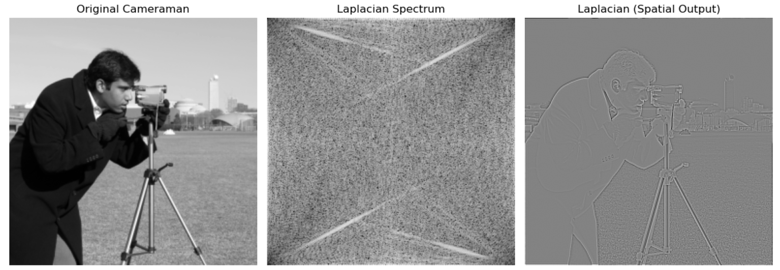

4- Assessment

The student will be asked to accomplish the following tasks within the lab time.

Task#1: Using the same Cameraman image, apply the Sobel filter(s) in the frequency domain and show the results.
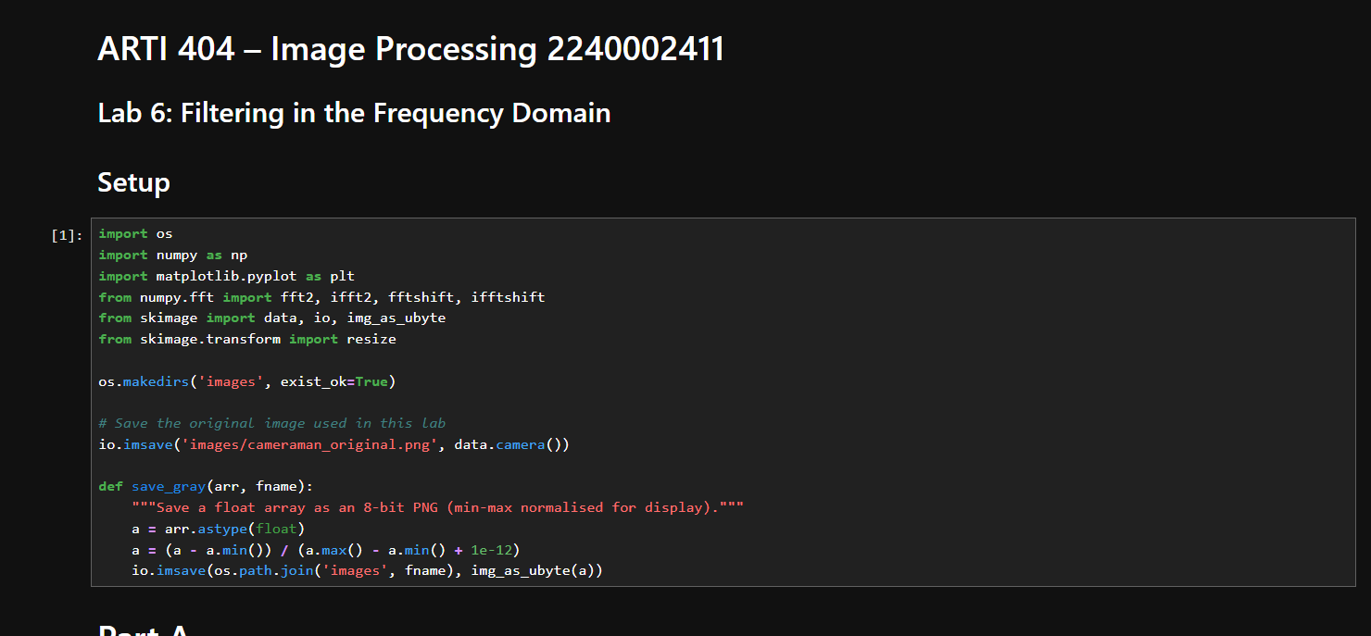
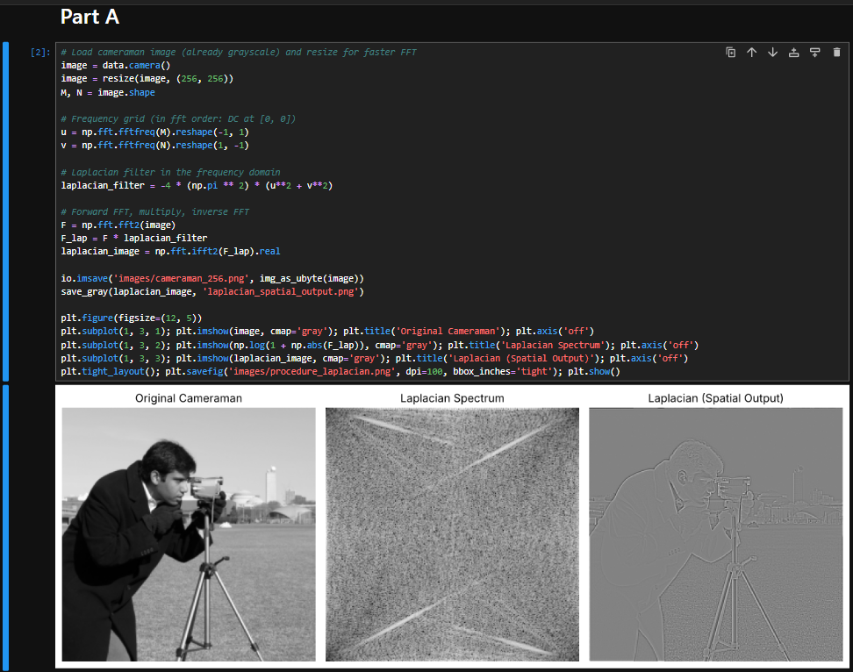
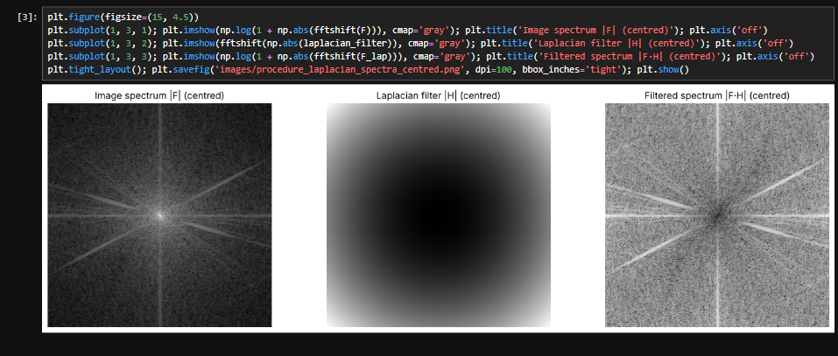
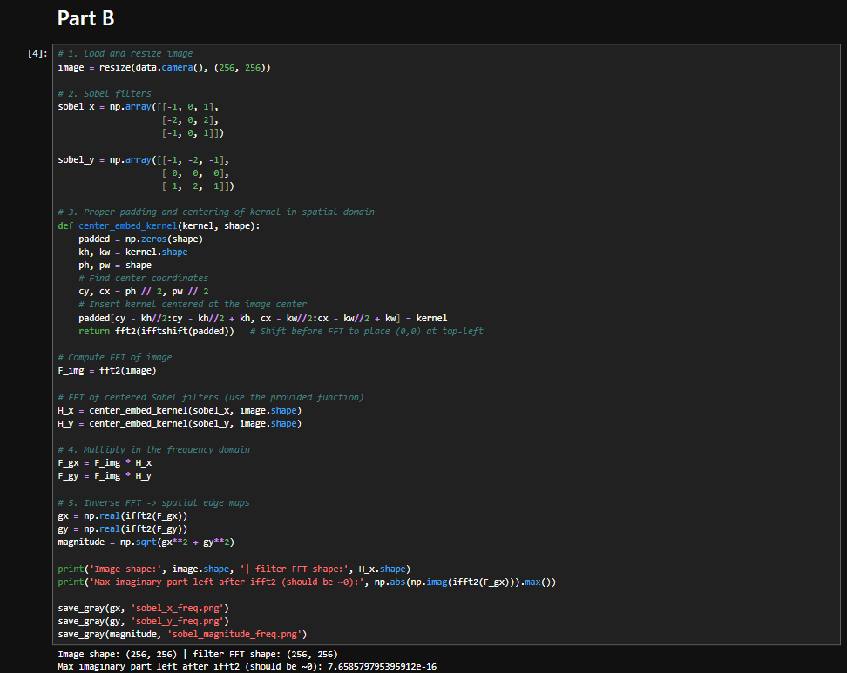
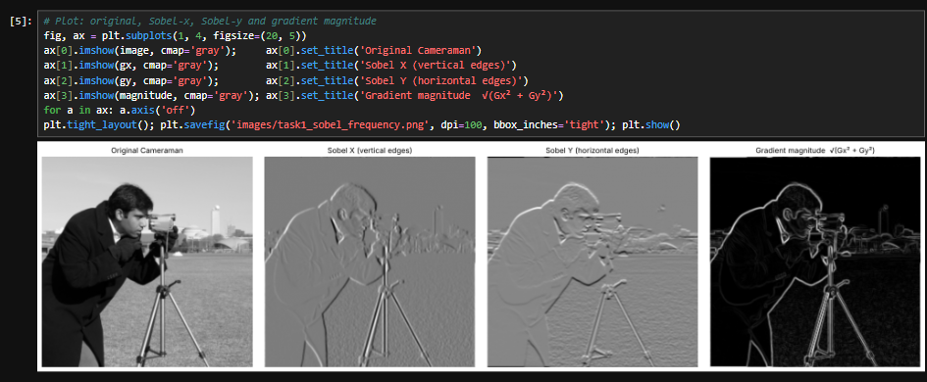
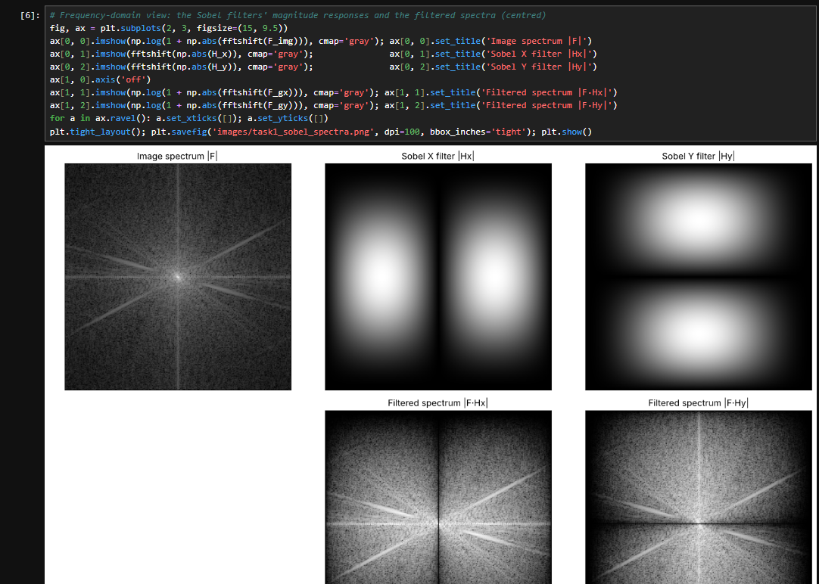
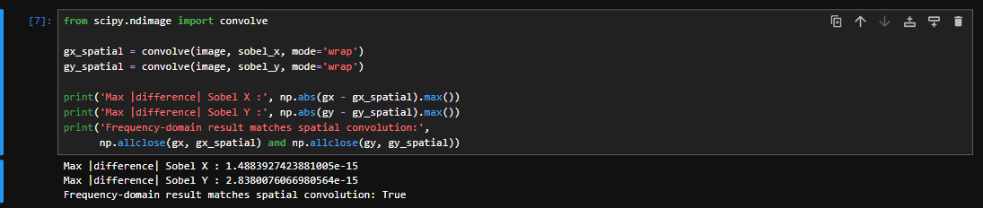
Hints:
# Load and resize image

# Sobel filters
sobel_x = np.array([[-1, 0, 1],
[-2, 0, 2],
[-1, 0, 1]])

sobel_y = np.array([[-1, -2, -1],
[ 0, 0, 0],
[ 1, 2, 1]])

# Proper padding and centering of kernel in spatial domain
def center_embed_kernel(kernel, shape):
padded = np.zeros(shape)
kh, kw = kernel.shape
ph, pw = shape
# Find center coordinates
cy, cx = ph // 2, pw // 2
# Insert kernel centered at the image center
padded[cy - kh//2:cy - kh//2 + kh, cx - kw//2:cx - kw//2 + kw] = kernel
return fft2(ifftshift(padded)) # Shift before FFT to place (0,0) at top-left

# Compute FFT of image

# FFT of centered Sobel filters (use the provided function)

# Multiply in the frequency domain

# Plot

Submission

The students need to submit the GitHub link via Blackboard. Make sure the Lab#6 folder contains the following files.

- Jupyter notebook and its PDF
- Images used

